

Title

By

(Author names and company Name and Logo)

Section 1.


Section 2.

Section 3.
Conclusions
Insert graph or image
References

Consortium:

GFT Italia S.r.l. (GFT), Italy Institut für angewandte Systemtechnik Bremen
KUKA AG (KUKA), Germany GmbH (Institute for Applied Systems Technology
Transportes Aereos Portugueses, S.A. Bremen GmbH) [ATB], Germany
(TAP), Portugal University of Piraeus Research Center
SIEMENS S.R.L (SIE), Romania [UPRC], Greece
SPACE HELLAS [SPACE], Greece Instituto Piaget - Cooperativa para o
Franz Schmidt + Haensch GmbH & Co. Desenvolvimento Humano Integral e Ecológico,
[SH] Germany CRL [IPIA], Portugal
Ekso S.r.l. [EKSO], Italy CYENS Centre of Excellence [CYENS], Cyprus
oculavis GmbH [OCU], Germany The Open Group Limited [TOG], UK
HOLO-Industrie 4.0 Software GmbH CORCOM IT Law Consulting [COR], Denmark
[HOLO], Germany Scuola Universitaria Professionale della
ImmersiveLives [IML], Portugal Svizzera Italiana [SUPSI], Switzerland
Synelixis Lyseis Pliroforikis Automatismou Almer Technologies AG [ALMER], Switzerland
& Tilepikoinonion Anonimi Etairia [SYN], Greece Switzerland Innovation Park Biel/Bienne AG
LeanXcale SL [LXS], Spain [SSF], Switzerland
UBITECH Ltd [UBI], Greece LNS Management Sàrl [LNS], Switzerland
Unparallel Innovation, Lda [UNP], Portugal
INNOV-ACTS Limited [INNOV], Cyprus

Contact:

Project Coordinator: Matteo Falsetta, GFT
Whitepaper Contact:
Dissemination Manager: Elina Papadopoulou, INNOV



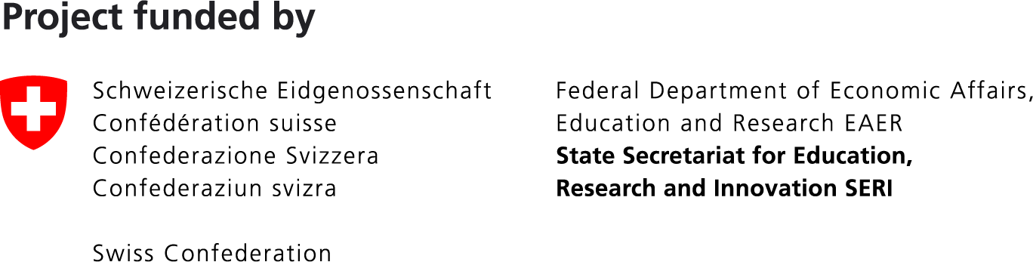

‘This work has received funding from the Swiss State
Secretariat for Education, Research and Innovation (SERI)’

